Acronyms

FSD-10 420-WA5-AB Class

May 16, 2023

John abbott college

Table of Contents

1. RAM - Random Access Memory 3

2. ROM - Read only memory 3

3. CPU - Central Processing Unit 4

4. MB - Megabyte 4

5. GB - Giga Byte 4

6. TB - Terabyte 5

7. PB - Petabyte 5

8. LAN - Local Area Network 6

9. LCD - Liquid-Crystal Display 6

10 UX - User Experience 7

11. UI - User Interface 7

12. IT - Information Technology 8

13. MIS - Management information systems 8

14. GUI - Graphical User Interface 9

15. BIT - Binary Digit 9

16. BCC - Blind carbon copy 10

17. EDI - Electronic Data Interchange 10

18.ISP - Internet Service Provider 11

19. CMS - Content Management System 11

20. URI - Uniform Resource Identifier 11

21. SEO - Search Engine Optimization 12

22. HTML - HyperText Markup Language 12

23. HTTPS - Hypertext Transfer Protocol Secure 13

24. BYOD - Bring your own device 13

25. URL - Uniform Resource Locator 13

26. NMS – Network Management System 14

27. HDD - Hard Disk Drive 14

28. I/O - Input / Output 15

29. AI - Artificial Intelligence 15

30. WAN - Wide-Area Network 16

31 TCP/IP - Transmission Control Protocol / Internet Protocol 16

32. SLA - Service Level Agreement 16

33. AWS - Amazon Web Services 17

34. DBMS - Database management system 17

35. SSD - Solid State Drive 18

36. SaaS - Software as a Service 18

37.GHz - GigaHertz 19

38. GUID - Globally Unique Identifier 19

39. C2C - Consumer to consumer 19

40. B2B - Business-To-Business 20

41. IOT - Internet of Things 20

42. IaaS - Infrastructure as a Service 21

43. UPS - Uninterruptible Power Supply 21

44. BPS - Bits per second 22

45. USB - Universal serial device 22

46. FTP - File Transfer Protocol 23

47. CSS - Cascading Style Sheets 23

48. VPN - Virtual Private Network 23

49. ASCII - American Code for Information Interchange 24

50. VOIP - Voice over Internet Protocol 24

51. O365 – Office 365 (Microsoft 365) 25

52 FAQ - Frequently Asked Questions 25

53. MFA - Multi-factor Authentication 26

54. DNS - Domain Name System 26

55. GPS - Global positioning system 27

56. NIC - Network Interface Card 27

57. W3C – The World Wide Web Consortium 27

58. PaaS - Platform as a service 28

59. VM - Virtual Machine 28

60. WAP - Wireless Access Protocol 29

61. CSV - Comma-Separated Values 29

62. JSON - JavaScript Object Notation 30

63. XML - Extensible Markup Language 30

# 1. RAM - Random Access Memory

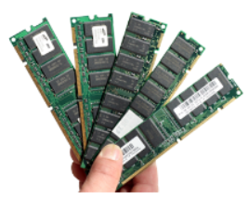

RAM is a common computing acronym that stands for **Random-Access Memory**. Sometimes it’s called PC memory or just memory. In essence, RAM is your computer or laptop’s short-term memory. It’s where the data is stored that your computer processor needs to run your applications and open your files.

Inside your computer, RAM typically comes in the form of a rectangular flat circuit board with memory chips attached, also referred to as a memory module. Computers typically come with at least two RAM modules with room to add more, if needed. These RAM modules are critical components that work hand in hand with your computer’s central processing unit (CPU) and must be working optimally for you to have a good experience.

<https://www.intel.ca/content/www/ca/en/tech-tips-and-tricks/computer-ram.html>

# 2. ROM - Read only memory



Read-only memory (ROM) is a type of non-volatile memory used in computers and other electronic devices. Data stored in ROM cannot be electronically modified after the manufacture of the memory device. Read-only memory is useful for storing software that is rarely changed during the life of the system, also known as firmware. Software applications (like video games) for programmable devices can be distributed as plug-in cartridges containing ROM.

<https://en.wikipedia.org/wiki/Read-only_memory>

# 3. CPU - Central Processing Unit

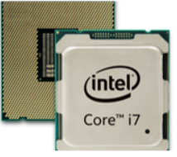

A central processing unit (CPU)—also called a central processor or main processor—is the most important processor in a given computer. Its electronic circuitry executes instructions of a computer program, such as arithmetic, logic, controlling, and input/output (I/O) operations. This role contrasts with that of external components, such as main memory and I/O circuitry, and specialized coprocessors such as graphics processing units (GPUs).

<https://en.wikipedia.org/wiki/Central_processing_unit>

# 4. MB - Megabyte

It is a standard unit in IT and digital technology that designates a file size or the capacity of a data storage medium. One megabyte is one million bytes of information.

<https://en.wikipedia.org/wiki/Megabyte>

# 5. GB - Giga Byte

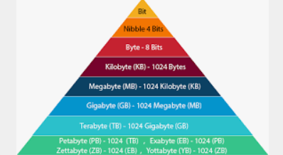

A gigabyte (GB) -- pronounced with two hard Gs -- is a unit of data storage capacity that is roughly equivalent to 1 billion bytes

https://www.techtarget.com/searchstorage/definition/gigabyte

# 6. TB - Terabyte

A terabyte (TB) is a unit of digital data that is equal to about 1 trillion bytes. In decimal notation (base 10), a terabyte is exactly 1 trillion bytes. In binary notation, a terabyte is equal to 240 bytes, or 1,099,511,627,776 bytes. The terabyte is typically used as a measure for storage capacity or the amount of stored data.

The prefix tera is derived from the Greek word for monster. It would take 728,177 floppy disks or 1,498 CDs to hold 1 TB of information. However, computers can now be configured with hard disk drives (HDDs) that offer more than 1 TB of capacity. Of course, many of today's systems, including desktops and laptops, come with solid-state drives (SSDs) instead of HDDs, yet even in this case, capacities are starting to reach terabyte levels.

<https://www.techtarget.com/searchstorage/definition/terabyte>

# 7. PB - Petabyte

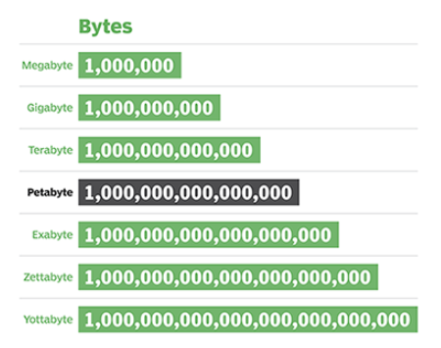

A petabyte (PB) is a unit of measurement in computers and similar electronic devices. One petabyte holds 1000 terabytes (TB) or 1,000,000,000,000,000 bytes.

<https://simple.wikipedia.org/wiki/Petabyte>

# 8. LAN - Local Area Network

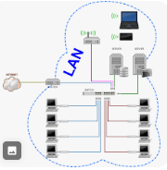

A local area network (LAN) is a collection of devices connected together in one physical location, such as a building, office, or home. A LAN can be small or large, ranging from a home network with one user to an enterprise network with thousands of users and devices in an office or school.

<https://www.cisco.com/c/en/us/products/switches/what-is-a-lan-local-area-network.html>

# 9. LCD - Liquid-Crystal Display

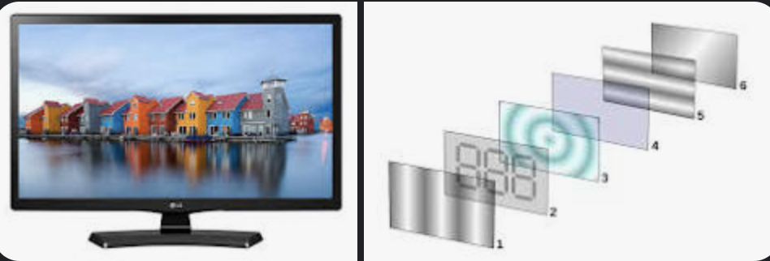

A liquid-crystal display (LCD) is a flat-panel display or other electronically modulated optical device that uses the light-modulating properties of liquid crystals combined with polarizers. Liquid crystals do not emit light directly[1] but instead use a backlight or reflector to produce images in color or monochrome.[2] LCDs are available to display arbitrary images (as in a general-purpose computer display) or fixed images with low information content, which can be displayed or hidden.

<https://en.wikipedia.org/wiki/Liquid-crystal_display>

# 10 UX - User Experience



The user experience (UX) is how a user interacts with and experiences a product, system or service. It includes a person's perceptions of utility, ease of use, and efficiency. Improving user experience is important to most companies, designers, and creators when creating and refining products because negative user experience can diminish the use of the product and, therefore, any desired positive impacts; conversely, designing toward profitability often conflicts with ethical user experience objectives and even causes harm. User experience is subjective. However, the attributes that make up the user experience are objective.

<https://en.wikipedia.org/wiki/User_experience>

# 11. UI - User Interface

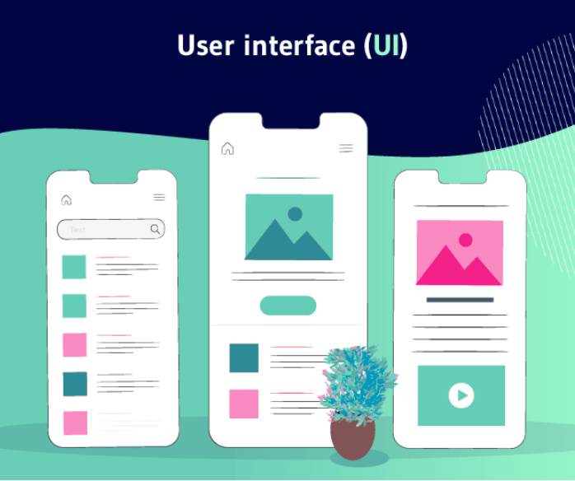

In the industrial design field of human–computer interaction, a user interface (UI) is the space where interactions between humans and machines occur. The goal of this interaction is to allow effective operation and control of the machine from the human end, while the machine simultaneously feeds back information that aids the operators' decision-making process. Examples of this broad concept of user interfaces include the interactive aspects of computer operating systems, hand tools, heavy machinery operator controls and process controls. The design considerations applicable when creating user interfaces are related to, or involve such disciplines as, ergonomics and psychology.

https://en.wikipedia.org/wiki/User_interface

# 12. IT - Information Technology



Information technology (IT) is the use of computers to create, process, store, retrieve and exchange all kinds of data and information. IT forms part of information and communications technology (ICT).

<https://en.wikipedia.org/wiki/Information_technology>

# 13. MIS - Management information systems

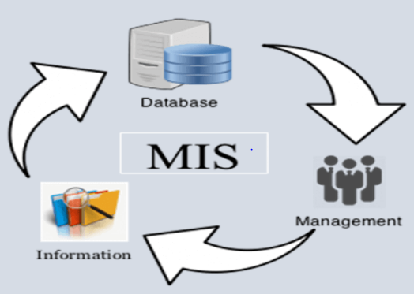

A management information system (MIS) is an [information system](https://en.wikipedia.org/wiki/Information_system) used for [decision-making](https://en.wikipedia.org/wiki/Decision-making), and for the coordination, control, analysis, and visualization of information in an organization. The study of the management information systems involves people, processes and technology in an organizational context.

<https://en.wikipedia.org/wiki/Management_information_system>

# 14. GUI - Graphical User Interface

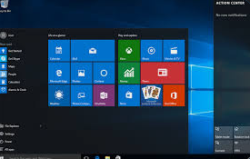

The graphical user interface, or GUI, is a form of user interface that allows users to interact with electronic devices through graphical icons and audio indicators such as primary notation, instead of text-based UIs, typed command labels or text navigation. GUIs were introduced in reaction to the perceived steep learning curve of command-line interfaces which require commands to be typed on a computer keyboard.

https://en.wikipedia.org/wiki/Graphical_user_interface

# 15. BIT - Binary Digit

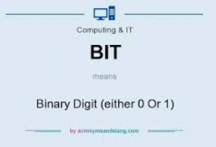

The bit is the most basic unit of information in computing and digital communications. The name is a portmanteau of binary digit. The bit represents a logical state with one of two possible values. These values are most commonly represented as either "1" or "0", but other representations such as true/false, yes/no, on/off, or +/− are also widely used.

<https://en.wikipedia.org/wiki/Bit>

# 16. BCC - Blind carbon copy

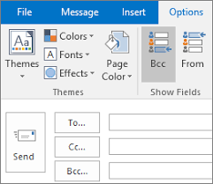

Blind carbon copy (abbreviated Bcc) allows the sender of a message to conceal the person entered in the Bcc field from the other recipients. This concept originally applied to paper correspondence and now also applies to email.

https://en.wikipedia.org/wiki/Blind_carbon_copy

# 17. EDI - Electronic Data Interchange

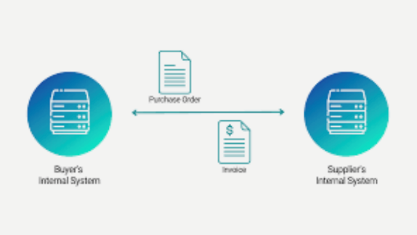

Is the concept of businesses electronically communicating information that was traditionally communicated on paper, such as purchase orders, advance ship notices, and invoices

https://en.wikipedia.org/wiki/Electronic_data_interchange

# 18.ISP - Internet Service Provider



An Internet service provider (ISP) is an organization that provides services for accessing, using, managing, or participating in the Internet. ISPs can be organized in various forms, such as commercial, community-owned, non-profit, or otherwise privately owned.

Internet services typically provided by ISPs can include Internet access, Internet transit, domain name registration, web hosting, Usenet service, and colocation.

<https://en.wikipedia.org/wiki/Internet_service_provider>

# 19. CMS - Content Management System

A content management system (CMS) is computer software used to create and modify digital content (content management). A CMS is typically used for enterprise content management (ECM) and web content management (WCM).

<https://en.wikipedia.org/wiki/Content_management_system>

# 20. URI - Uniform Resource Identifier

A Uniform Resource Identifier (URI) is a unique sequence of characters that identifies a logical or physical resource used by web technologies. URIs may be used to identify anything, including real-world objects, such as people and places, concepts, or information resources such as web pages and books. Some URIs provide a means of locating and retrieving information resources on a network (either on the Internet or on another private network, such as a computer filesystem or an Intranet); these are Uniform Resource Locators (URLs). A URL provides the location of the resource. A URI identifies the resource by name at the specified location or URL. Other URIs provide only a unique name, without a means of locating or retrieving the resource or information about it, these are Uniform Resource Names (URNs). The web technologies that use URIs are not limited to web browsers. URIs are used to identify anything described using the Resource Description Framework (RDF), for example, concepts that are part of an ontology defined using the Web Ontology Language (OWL), and people who are described using the Friend of a Friend vocabulary would each have an individual URI.

<https://en.wikipedia.org/wiki/Uniform_Resource_Identifier>

# 21. SEO - Search Engine Optimization

Search engine optimization (SEO) is the process of improving the quality and quantity of website traffic to a website or a web page from search engines.[1][2] SEO targets unpaid traffic (known as "natural" or "organic" results) rather than direct traffic or paid traffic. Unpaid traffic may originate from different kinds of searches, including image search, video search, academic search,[3] news search, and industry-specific vertical search engines.

<https://en.wikipedia.org/wiki/Search_engine_optimization>

# 22. HTML - HyperText Markup Language

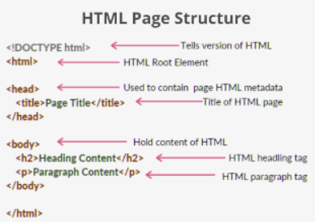

HyperText Markup Language or HTML is the standard markup language for documents designed to be displayed in a web browser. It is often assisted by technologies such as Cascading Style Sheets (CSS) and scripting languages such as JavaScript.

<https://en.wikipedia.org/wiki/HTML>

# 23. HTTPS - Hypertext Transfer Protocol Secure

Hypertext Transfer Protocol Secure (HTTPS) is an extension of the Hypertext Transfer Protocol (HTTP). It uses encryption for secure communication over a computer network, and is widely used on the Internet.[1][2] In HTTPS, the communication protocol is encrypted using Transport Layer Security (TLS) or, formerly, Secure Sockets Layer (SSL). The protocol is therefore also referred to as HTTP over TLS,[3] or HTTP over SSL.

<https://en.wikipedia.org/wiki/HTTPS>

# 24. BYOD - Bring your own device

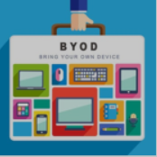

BYOD, for “bring your own device,” refers to corporate IT policy that determines when and how employees, contractors, and other authorized end users can use their own laptops, smartphones and other personal devices on the company network to access corporate data and perform their job duties.

<https://www.ibm.com/topics/byod>

# 25. URL - Uniform Resource Locator

A URL is nothing more than the address of a given unique resource on the Web. In theory, each valid URL points to a unique resource. Such resources can be an HTML page, a CSS document, an image, etc. In practice, there are some exceptions, the most common being a URL pointing to a resource that no longer exists or that has moved. As the resource represented by the URL and the URL itself are handled by the Web server, it is up to the owner of the web server to carefully manage that resource and its associated URL.

<https://developer.mozilla.org/en-US/docs/Learn/Common_questions/Web_mechanics/What_is_a_URL>

# 26. NMS – Network Management System

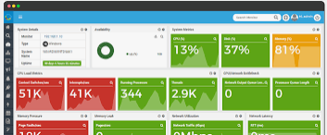

NMS is a system designed for monitoring, maintaining, and optimizing a network. It includes both hardware and software, but most often an NMS refers to the software used to manage a network.

<https://techterms.com/definition/nms>

# 27. HDD - Hard Disk Drive

A hard disk drive (HDD), hard disk, hard drive, or fixed disk, is an electro-mechanical data storage device that stores and retrieves digital data using magnetic storage with one or more rigid rapidly rotating platters coated with magnetic material. The platters are paired with magnetic heads, usually arranged on a moving actuator arm, which read and write data to the platter surfaces. Data is accessed in a random-access manner, meaning that individual blocks of data can be stored and retrieved in any order. HDDs are a type of non-volatile storage, retaining stored data when powered off. Modern HDDs are typically in the form of a small rectangular box.

<https://en.wikipedia.org/wiki/Hard_disk_drive>

# 28. I/O - Input / Output

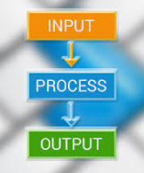

In computing, input/output (I/O, i/o, or informally io or IO) is the communication between an information processing system, such as a computer, and the outside world, possibly a human or another information processing system. Inputs are the signals or data received by the system and outputs are the signals or data sent from it. The term can also be used as part of an action; to "perform I/O" is to perform an input or output operation.

https://en.wikipedia.org/wiki/Input/output

# 29. AI - Artificial Intelligence

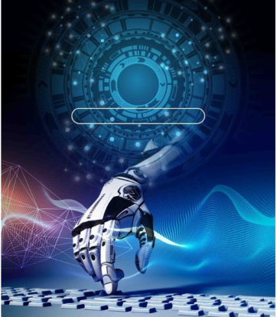

Artificial intelligence (AI) is [intelligence](https://en.wikipedia.org/wiki/Intelligence)—perceiving, synthesizing, and inferring information—demonstrated by [machines](https://en.wikipedia.org/wiki/Machine), as opposed to [intelligence displayed by humans](https://en.wikipedia.org/wiki/Human_intelligence) or [by other animals](https://en.wikipedia.org/wiki/Animal_cognition). Example tasks in which this is done include speech recognition, computer vision, translation between (natural) languages, as well as other mappings of inputs.

<https://en.wikipedia.org/wiki/Artificial_intelligence>

# 30. WAN - Wide-Area Network

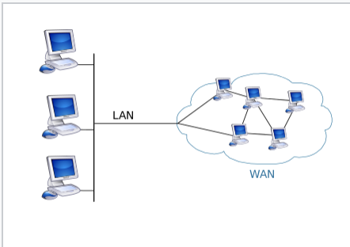

A wide area network (WAN) is a telecommunications network that extends over a large geographic area. Wide area networks are often established with leased telecommunication circuits.

https://en.wikipedia.org/wiki/Wide_area_network#cite_note-1

# 31 TCP/IP - Transmission Control Protocol / Internet Protocol

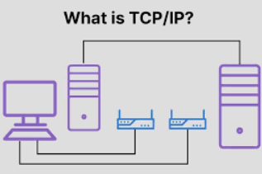

The Internet protocol suite, commonly known as TCP/IP, is a framework for organizing the set of communication protocols used in the Internet and similar computer networks according to functional criteria. The foundational protocols in the suite are the Transmission Control Protocol (TCP), the User Datagram Protocol (UDP), and the Internet Protocol (IP).

<https://en.wikipedia.org/wiki/Internet_protocol_suite>

# 32. SLA - Service Level Agreement



A service-level agreement (SLA) is a commitment between a service provider and a customer. Particular aspects of the service – quality, availability, responsibilities – are agreed between the service provider and the service user.[1] The most common component of an SLA is that the services should be provided to the customer as agreed upon in the contract. As an example, Internet service providers and telcos will commonly include service level agreements within the terms of their contracts with customers to define the level(s) of service being sold in plain language terms.

<https://en.wikipedia.org/wiki/Service-level_agreement>

# 33. AWS - Amazon Web Services

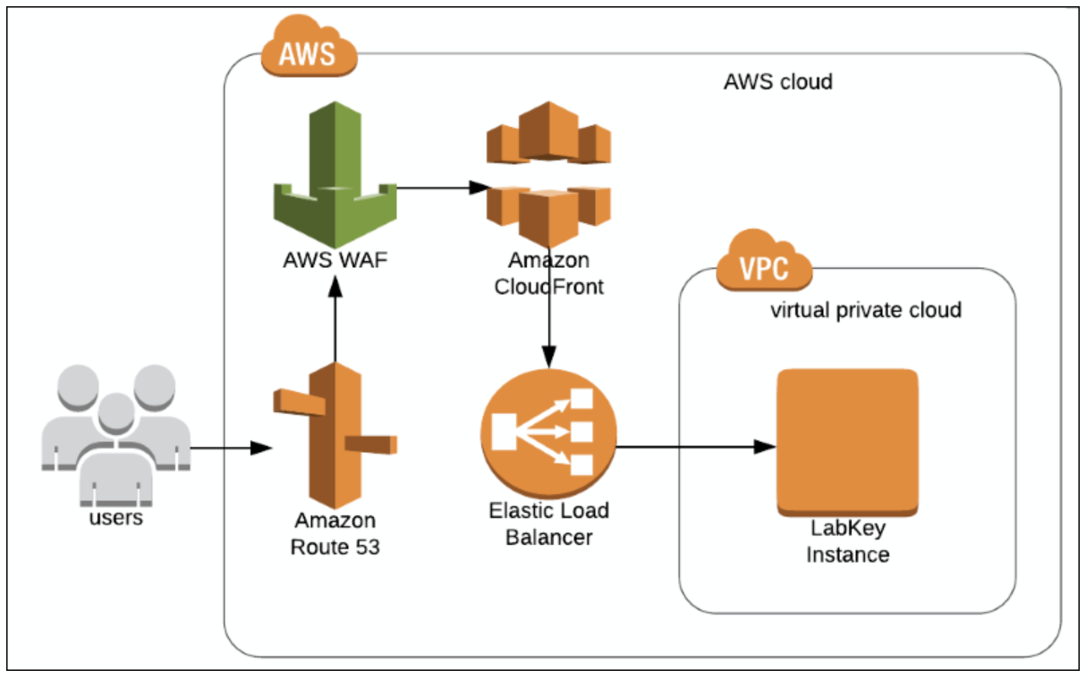

Amazon Web Services, Inc. (AWS) is a subsidiary of Amazon that provides on-demand cloud computing platforms and APIs to individuals, companies, and governments, on a metered, pay-as-you-go basis. Often times, clients will use this in combination with autoscaling (a process that allows a client to use more compute in times of high application usage, and then scale down to reduce costs when there is less traffic).

<https://en.wikipedia.org/wiki/Amazon_Web_Services>

# 34. DBMS - Database management system

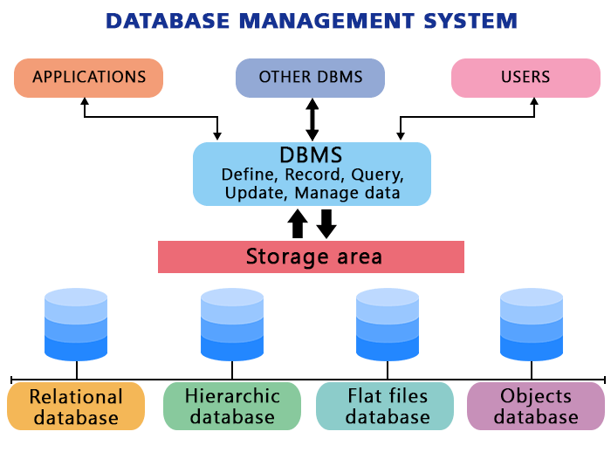

A database management system (or DBMS) is essentially nothing more than a computerized data-keeping system. Users of the system are given facilities to perform several kinds of operations on such a system for either manipulation of the data in the database or the management of the database structure itself. Database Management Systems (DBMSs) are categorized according to their data structures or types.

<https://www.ibm.com/docs/en/zos-basic-skills?topic=zos-what-is-database-management-system>

# 35. SSD - Solid State Drive

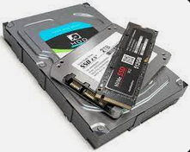

A solid-state drive (SSD) is a solid-state storage device that uses integrated circuit assemblies to store data persistently, typically using flash memory, and functioning as secondary storage in the hierarchy of computer storage. It is also sometimes called a semiconductor storage device, a solid-state device or a solid-state disk, even though SSDs lack the physical spinning disks and movable read-write heads used in hard disk drives (HDDs) and floppy disks. SSD also has rich internal parallelism for data processing.

https://en.wikipedia.org/wiki/Solid-state_drive

# 36. SaaS - Software as a Service

Software as a service (SaaS /sæs/[1]) is a software licensing and delivery model in which software is licensed on a subscription basis and is centrally hosted. SaaS is also known as on-demand software, web-based software, or web-hosted software.

SaaS is considered to be part of cloud computing, along with infrastructure as a service (IaaS), platform as a service (PaaS), desktop as a service (DaaS), managed software as a service (MSaaS), mobile backend as a service (MBaaS), data center as a service (DCaaS), integration platform as a service (iPaaS), and information technology management as a service (ITMaaS).

<https://en.wikipedia.org/wiki/Software_as_a_service>

# 37.GHz - GigaHertz



The hertz (symbol: Hz) is the unit of frequency in the International System of Units (SI), equivalent to one event (or cycle) per second.The hertz is an SI derived unit whose expression in terms of SI base units is s−1, meaning that one hertz is the reciprocal of one second. It is named after Heinrich Rudolf Hertz (1857–1894), the first person to provide conclusive proof of the existence of electromagnetic waves. Hertz are commonly expressed in multiples: kilohertz (kHz), megahertz (MHz), gigahertz (GHz), terahertz (THz).

https://en.wikipedia.org/wiki/Hertz

# 38. GUID - Globally Unique Identifier

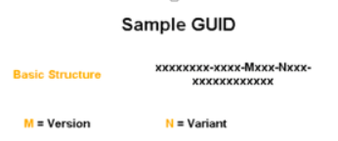

When generated according to the standard methods, UUIDs are, for practical purposes, unique. Their uniqueness does not depend on a central registration authority or coordination between the parties generating them, unlike most other numbering schemes.

https://en.wikipedia.org/wiki/Universally_unique_identifier

# 39. C2C - Consumer to consumer



C2C represents a market environment where one customer purchases goods from another customer using a third-party business or platform to facilitate the transaction. C2C companies are a type of business model that emerged with e-commerce technology and the sharing economy.

https://www.investopedia.com/terms/c/ctoc.asp

# 40. B2B - Business-To-Business

B2B (business-to-business), a type of electronic commerce (e-commerce), is the exchange of products, services, or information between businesses, rather than between businesses and consumers (B2C).

[https://www.techtarget.com/searchcio/defi nition/B2B](https://www.techtarget.com/searchcio/defi%20nition/B2B)

# 41. IOT - Internet of Things

The Internet of Things (IoT) describes the network of physical objects—“things”—that are embedded with sensors, software, and other technologies for the purpose of connecting and exchanging data with other devices and systems over the internet. These devices range from ordinary household objects to sophisticated industrial tools. With more than 7 billion connected IoT devices today, experts are expecting this number to grow to 10 billion by 2020 and 22 billion by 2025.

<https://www.oracle.com/ca-en/internet-of-things/what-is-iot/>

# 42. IaaS - Infrastructure as a Service

Infrastructure as a service (IaaS) is a cloud computing service model by means of which computing resources are supplied by a cloud services provider. The IaaS vendor provides the storage, network, servers, and virtualization (which mostly refers, in this case, to emulating computer hardware). This service enables users to free themselves from maintaining an on-premises data center. The IaaS provider is hosting these resources in either the public cloud (meaning users share the same hardware, storage, and network devices with other users), the private cloud (meaning users do not share these resources), or the hybrid cloud (combination of both).

https://en.wikipedia.org/wiki/Infrastructure_as_a_service

# 43. UPS - Uninterruptible Power Supply

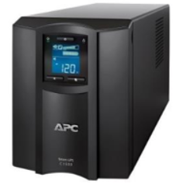

Uninterruptible Power Supply, a device that provides battery backup when the electrical power fails or drops to an unacceptable voltage level. Small UPS systems provide power for a few minutes; enough to power down the computer in an orderly manner, while larger systems have enough battery for several hours. In mission critical datacenters, UPS systems are used for just a few minutes until electrical generators take over.

UPS systems can be set up to alert file servers to shut down in an orderly manner when an outage has occurred, and the batteries are running out.

<https://www.pcmag.com/encyclopedia/term/UPS>

# 44. BPS - Bits per second

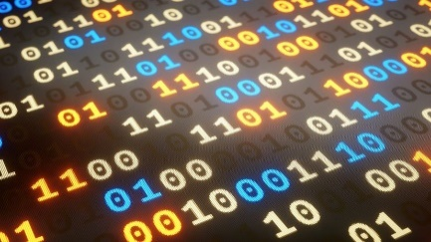

In data communications, bits per second (bps or bit/sec) is a common measure of data speed for computer modems and transmission carriers. As the term implies, the speed in bps is equal to the number of bits transmitted or received each second.

<https://www.techtarget.com/searchnetworking/definition/bits-per-second>

# 45. USB - Universal serial device

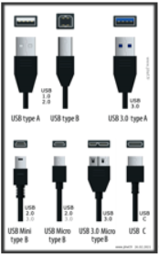

Universal Serial Bus (USB) is an industry standard that specifies the physical interfaces and protocols for connecting, data transferring and powering of hosts, such as personal computers, peripherals, e.g. keyboards and mobile devices, and intermediate hubs. USB was designed to standardize the connection of peripherals to computers, replacing various interfaces such as serial ports, parallel ports, game ports, and ADB ports. It has become commonplace on a wide range of devices, such as keyboards, mice, cameras, printers, scanners, flash drives, smartphones, game consoles, and power banks.

<https://en.wikipedia.org/wiki/USB>

# 46. FTP - File Transfer Protocol

It is a standard communication protocol used for the transfer of computer files from a server to a client on a computer network. FTP is built on a client-server model architecture using separate control and data connections between the client and the server.

<https://en.wikipedia.org/wiki/File_Transfer_Protocol>

# 47. CSS - Cascading Style Sheets

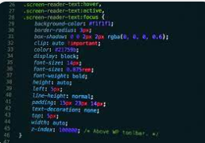

Cascading Style Sheets (CSS) is a style sheet language used for describing the presentation of a document written in a markup language such as HTML or XML (including XML dialects such as SVG, MathML or XHTML).[1] CSS is a cornerstone technology of the World Wide Web, alongside HTML and JavaScript.[2]

https://en.wikipedia.org/wiki/CSS

# 48. VPN - Virtual Private Network

A virtual private network (VPN) is a mechanism for creating a secure connection between a computing device and a computer network, or between two networks, using an insecure communication medium such as the public Internet.

A VPN can extend a private network (one that disallows or restricts public access), in such a way that it enables users of that network to send and receive data across public networks as if the public networks' devices were directly connected to the private network. The benefits of a VPN include security, reduced costs for dedicated communication lines, and greater flexibility for remote workers. VPNs are also used to bypass internet censorship. Encryption is common, although not an inherent part of a VPN connection.

https://en.wikipedia.org/wiki/Virtual_private_network

# 49. ASCII - American Code for Information Interchange

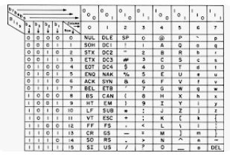

The American Code for Information Interchange, commonly called ASCII, is a computer language for text that became the standard for transmitting information between computers in 1963.

The ASCII system translates alphanumeric characters and symbols into a computer-readable code. The original ASCII was English-only. There are now two types of ASCII codes; the standard code that uses a seven-bit encoding system, and an extended code that uses an eight-bit system.

It is pronounced ASK-y.

https://www.investopedia.com/terms/a/american-code-for-information-interchange.asp

# 50. VOIP - Voice over Internet Protocol

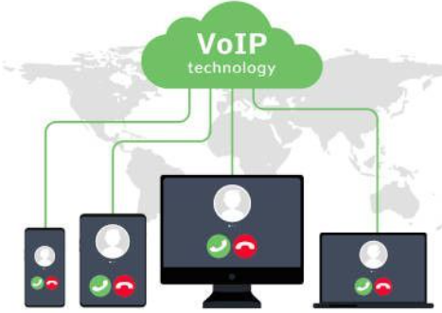

Voice over Internet Protocol (VoIP), also called IP telephony, is a method and group of technologies for the delivery of [voice communications](https://en.wikipedia.org/wiki/Speech) and [multimedia](https://en.wikipedia.org/wiki/Multimedia) sessions over [Internet Protocol](https://en.wikipedia.org/wiki/Internet_Protocol) (IP) networks, such as the [Internet](https://en.wikipedia.org/wiki/Internet). The terms Internet telephony, broadband telephony, and broadband phone service specifically refer to the provisioning of communications services (voice, [fax](https://en.wikipedia.org/wiki/Fax), [SMS](https://en.wikipedia.org/wiki/Short_Message_Service), voice-messaging) over the Internet, rather than via the [public switched telephone network](https://en.wikipedia.org/wiki/Public_switched_telephone_network) (PSTN), also known as [plain old telephone service](https://en.wikipedia.org/wiki/Plain_old_telephone_service) (POTS).

<https://en.wikipedia.org/wiki/Voice_over_IP>

# 51. O365 – Office 365 (Microsoft 365)

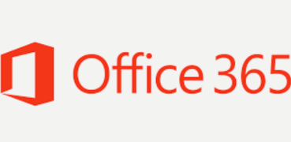

Office 365 (currently known as Microsoft 365) is the cloud-powered productivity platform that includes apps like Microsoft Teams, Word, Excel, PowerPoint, Outlook, OneDrive, and so much more. [1]

Microsoft 365 is a product family of productivity software, collaboration and cloud-based services owned by Microsoft. It encompasses online services such as Outlook.com, OneDrive, Microsoft Teams, programs formerly marketed under the name Microsoft Office (including applications such as Word, Excel, PowerPoint, and Outlook on Microsoft Windows, macOS, mobile devices, and on the web), enterprise products and services associated with these products such as Exchange Server, SharePoint, and Yammer. It also covers subscription plans encompassing these products, including those that include subscription-based licenses to desktop and mobile software, and hosted email and intranet services. [2]

[1] <https://www.microsoft.com/en-CA/microsoft-365/microsoft-365-faqs>

[2] <https://en.wikipedia.org/wiki/Microsoft_365>

# 52 FAQ - Frequently Asked Questions



A frequently asked questions (FAQ) list is often used in articles, websites, email lists, and online forums where common questions tend to recur, for example through posts or queries by new users related to common knowledge gaps.

<https://en.wikipedia.org/wiki/FAQ>

# 53. MFA - Multi-factor Authentication

Multi-factor authentication is an electronic authentication method in which a user is granted access to a website or application only after successfully presenting two or more pieces of evidence (or factors) to an authentication mechanism: knowledge (something only the user knows), possession (something only the user has), and inherence (something only the user is). MFA protects user data—which may include personal identification or financial assets—from being accessed by an unauthorized third party that may have been able to discover, for example, a single password.

https://en.wikipedia.org/wiki/Multi-factor_authentication

# 54. DNS - Domain Name System

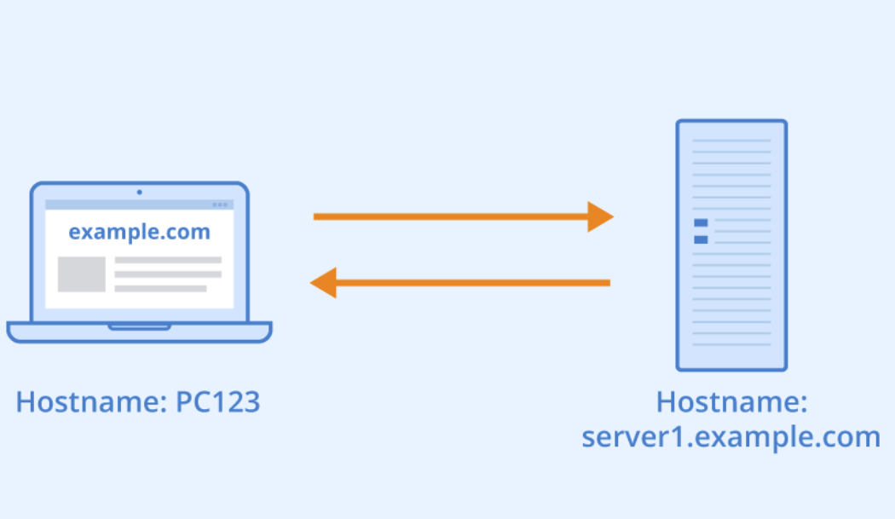

The Domain Name System (DNS) is a hierarchical and distributed naming system for computers, services, and other resources in the Internet or other Internet Protocol (IP) networks. It associates various information with domain names assigned to each of the associated entities. Most prominently, it translates readily memorized domain names to the numerical IP addresses needed for locating and identifying computer services and devices with the underlying network protocols.[1] The Domain Name System has been an essential component of the functionality of the Internet since 1985.

<https://en.wikipedia.org/wiki/Domain_Name_System>

# 55. GPS - Global positioning system

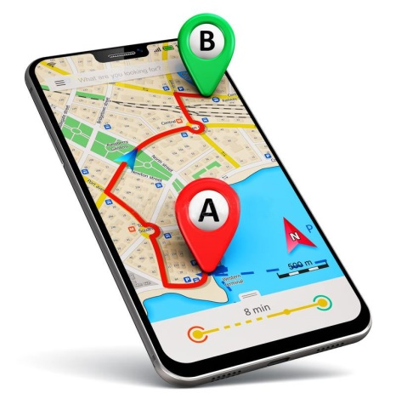

Global Positioning System is a network of satellites that helps users determine a location on Earth. The thought of GPS was conceived after the launch of Sputnik in [1957](https://www.computerhope.com/history/1957.htm). In [1964](https://www.computerhope.com/history/1964.htm), the TRANSIT system became operational on U.S. Polaris submarines and allowed for accurate positioning updates. Later this became available for commercial use in [1967](https://www.computerhope.com/history/1967.htm). The picture shows an example of the GARMIN nuvi 350, a GPS used to find locations while driving.

<https://www.computerhope.com/jargon/g/gps.htm>

# 56. NIC - Network Interface Card

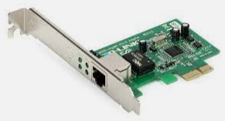

A network interface controller (NIC, also known as a network interface card, network adapter, LAN adapter or physical network interface, and by similar terms) is a computer hardware component that connects a computer to a computer network.

https://en.wikipedia.org/wiki/Network_interface_controller

# 57. W3C – The World Wide Web Consortium

The World Wide Web Consortium (W3C) is the main international standards organization for the World Wide Web. Founded in 1994 and led by Tim Berners-Lee, the consortium is made up of member organizations that maintain full-time staff working together in the development of standards for the World Wide Web. As of 5 March 2023, W3C had 462 members. W3C also engages in education and outreach, develops software and serves as an open forum for discussion about the Web.

<https://en.wikipedia.org/wiki/World_Wide_Web_Consortium>

# 58. PaaS - Platform as a service

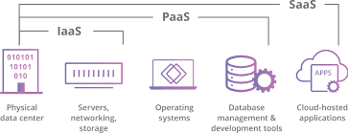

Platform as a service (PaaS) or application platform as a service (aPaaS) or platform-based service is a category of cloud computing services that allows customers to provision, instantiate, run, and manage a modular bundle comprising a computing platform and one or more applications, without the complexity of building and maintaining the infrastructure typically associated with developing and launching the application(s), and to allow developers to create, develop, and package such software bundles.

https://en.wikipedia.org/wiki/Platform_as_a_service

# 59. VM - Virtual Machine

Image

In computing, a "virtual machine" is the virtualization or emulation of a computer system. Virtual machines are based on computer architectures and provide the functionality of a physical computer.

https://en.wikipedia.org/wiki/Virtual_machine

# 60. WAP - Wireless Access Protocol

**Wireless Application Protocol (WAP) is a technical standard for accessing information over a mobile wireless network. A WAP browser is a web browser for mobile devices such as mobile phones that use the protocol. Introduced in 1999,[1] WAP achieved some popularity in the early 2000s, but by the 2010s it had been largely superseded by more modern standards. Almost all modern handset internet browsers now fully support HTML, so they do not need to use WAP markup for web page compatibility, and therefore, most are no longer able to render and display pages written in WML, WAP's markup language.[2]**

[Wireless Application Protocol - Wikipedia](https://en.wikipedia.org/wiki/Wireless_Application_Protocol#:~:text=Wireless%20Application%20Protocol%20%28WAP%29%20is%20a%20technical%20standard,such%20as%20mobile%20phones%20that%20use%20the%20protocol.)

# 61. CSV - Comma-Separated Values

A comma-separated values (CSV) file is a delimited text file that uses a comma to separate values. Each line of the file is a data record. Each record consists of one or more fields, separated by commas. The use of the comma as a field separator is the source of the name for this file format. A CSV file typically stores tabular data (numbers and text) in plain text, in which case each line will have the same number of fields.

<https://en.wikipedia.org/wiki/Comma-separated_values>

# 62. JSON - JavaScript Object Notation

JSON (JavaScript Object Notation) is a lightweight data-interchange format. It is easy for humans to read and write. It is easy for machines to parse and generate. It is based on a subset of the JavaScript Programming Language Standard ECMA-262 3rd Edition - December 1999. JSON is a text format that is completely language independent but uses conventions that are familiar to programmers of the C-family of languages, including C, C++, C#, Java, JavaScript, Perl, Python, and many others. These properties make JSON an ideal data-interchange language.

https://www.json.org/json-en.html

# 63. XML - Extensible Markup Language

Extensible Markup Language (XML) is a markup language and file format for storing, transmitting, and reconstructing arbitrary data. It defines a set of rules for encoding documents in a format that is both human-readable and machine-readable. The World Wide Web Consortium's XML 1.0 Specification of 1998 and several other related specifications—all of them free open standards—define XML.

<https://en.wikipedia.org/wiki/XML>